USHC 6.1 Explain the impact of the changes in the 1920s on the economy, society, and culture, including the expansion of mass production techniques, the invention of new home appliances, the introduction of the installment plan, the role of transportation in changing urban life, the effect of radio and movies in creating a national mass culture, and the cultural changes exemplified by the Harlem Renaissance.
A BOOMING ECONOMY! | The Losers:
The U.S. experienced unprecedented economic growth during the 1920s, but not everyone shared in the prosperity. There was a widening GAP between the  “haves” and the “have nots.” | 1.  (low crop prices)  2.  (anti-union sentiment)

Mass Production

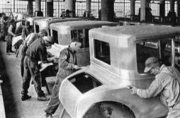

Henry Ford’s Line made production more efficient but cut out the need for skilled laborers. Automobiles became prevalent during the 1920s because of Ford’s assembly line.
Many other products, such as and , were mass produced on assembly lines.

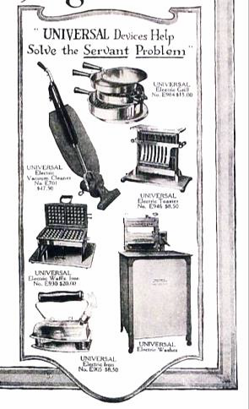
Household Appliances and Consumer Culture
New electric appliances, such as the vacuum cleaner, iron, and washing machine made it easier than ever for housewives to do household chores.
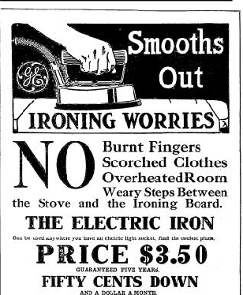ADVERTISING!!!

NOW
Pay !
Americans who couldn’t afford the
new appliances purchased them on the
plan.
RESULT:

African Americans in the 1920s

The Great Migration | Music | Renaissance | Stereotyping in Film
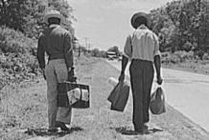 | 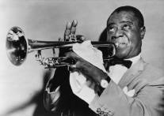 | An African American artistic and literary movement.  Hughes  (Famous Writer) | Birth of a Nation  (Popular film promoted racial stereotypes and made the KKK appear heroic.)
Black Americans leave the  South to  Search for Escape | Black musicians played for white audiences,  leading to some cultural exchange.

