USHC 6.2 Explain the causes and effects of the social change and conflict between traditional and modern culture that took place during the 1920s, including the role of women, the “Red Scare”, the resurgence of the Ku Klux Klan, immigration quotas, Prohibition, and the Scopes trial.

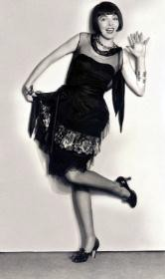
The Role of Women
Although women could vote in the 1920s thanks to the passage of the th Amendment, women made little impact on politics, typically voting the same way as their husbands did.
Many young women, known as , challenged cultural norms of
“ladylike” behavior. Flappers could be identified by their short hair, knee-length skirts, and their permissive lifestyles.
Flapper culture had very little impact on women, as a whole, as most women either stayed at home and made use of their new electrical appliance or worked menial jobs

where they were paid less than men.

Nativism

A “Flapper”

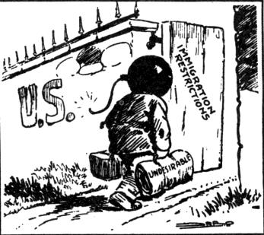 - Fear of Foreigners
American nativism reached a new peak in the 1920s due to the effects of WWI propaganda and the Revolution in 1917.
This political cartoon showcases American fears that many of the “New Immigrants” from Southern and Eastern Europe were
, , or .

[First] Red Scare | Immigration Quota Acts | Sacco and Vanzetti Trial
FEAR of a takeover of the United States  Raids (4000 alleged communists arrested – hundreds deported) | Placed quotas on immigration from  and  Europe  (New Immigrants) | Two immigrants were found guilty of murder and executed based on questionable evidence of guilt

Prohibition

ORIGINS: Movement (Antebellum Period)
Prohibition gained traction during WWI due to anti-German sentiment and the wartime push to conserve grain (the primary ingredient in beer and liquor).

th Amendment  Banned the sale and consumption of “intoxicating liquors” | ENFORCEMENT UNSUCCESSFUL |  | st Amendment  REPEALED the 18th Amendment (1933)
 | Illegal alcohol sellers  (e.g., Al Capone) | Private clubs where alcohol was illegally consumed

The Scopes “ ” Trial
FACT: The phrase, “Monkey Trial,” was coined by H.L. Mencken, a reporter covering the trial for the Baltimore Sun.
QUESTION:
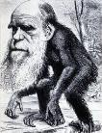
How do we explain the origins of humanity?

Religious _  “Conservative” |  | Modern Science  “Liberal”
The  contains a literal and true account of creation by God. | VS. | Charles  Theory of

In 1925, the Tennessee legislature passed a law forbidding the teaching of Charles Darwin’s theory of in public schools.
John Scopes, a substitute teacher and football coach, taught a lesson on evolution so that the town of Dayton, Tenn., could host a trial. The trial received national media coverage.

William Jennings Bryan, a Fundamentalist, volunteered to prosecute the case against  Scopes. | Scopes was defended by an attorney from the  A C L U .

The [Second] Ku Klux Klan

Nativist sentiment and the success of the film, Birth of a Nation, laid the groundwork for a
revival of the Ku Klux Klan. Members of the “Second” Ku Klux Klan cast themselves as the
guardians of “One Hundred Percent ”
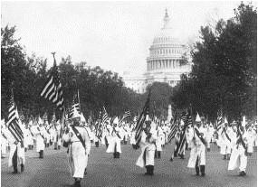
“TRUE AMERICAN” | “UNAMERICAN”
1.  2. Born 3. | 1.  - Born  - or Jewish

The Klan considered anyone “Un-American” who did not fit the “WASP” [White Anglo-Saxon Protestant] profile. Note that while the Klan was a white supremacist organization, it also targeted immigrants and religious minorities.

Klan members march on Washington in the 1920s.

MORAL WATCHDOG: The Klan also supported Prohibition, opposed bootlegging and gambling, and held its members of high moral standards. This function of the Klan was
undermined by scandals involving its members in the late 1920s and early 1930s.

NATIONWIDE: The Klan’s membership exceeded four million in the 1920s, and the
organization was stronger in the (Indiana, Ohio, etc.) than it was in the South.

