Name: ___________________________ Date: ________________ Period: ___

The Transcontinental Railroads
The Civil War was a turning point in the economic history of the United States. When Southern states seceded from the Union, Congress lost many of its members who believed in the Jeffersonian vision of a limited government and a laissez-faire economy. The Republican majority shared Hamilton’s vision of an active government that would provide direct funding for internal improvements.
The federal government sought to encourage the settlement of the West and used grants to encourage Western settlement and economic development. The federal government owned (and still owns) most of the land in the West and passed legislation aimed at populating and developing the West:

ACT | Provided Western settlers with 160 acre parcels of land for free as long as they improved and developed it
RAILWAY ACT | Granted land subsidies to corporations involved in building a  transcontinental railroad

The railroads linked the Eastern and Western United States and helped to create a national market.

WESTERN US | EASTERN US
The government-led development did not come without a price. Corporations schemed to get as much government money as possible, with some even resorting to fraud (e.g., Credit Mobilier Scandal).

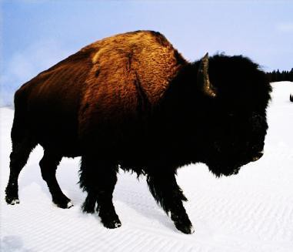
Subjugation of the Western Indian Tribes
The Indians depended on buffalo herds as their primary source of food. Unfortunately, buffalo herds and railroads cannot coexist. The railroad companies hired men like “Buffalo Bill” Cody to shoot bison in order to clear the way (and to feed railroad workers).

The Plains Indians were forced to live on , often away from their ancestral lands (these lands often had gold and

silver deposits). These Indians, unable to hunt for food, became dependent on the federal government, which took advantage of them.

The Act took Indian lands away from the tribes and gave parcels to individual Indian families in return for U.S. citizenship.
Buffalo herds and railroads cannot coexist.

The goal of the Dawes Act was to encourage the of Native Americans (get them to adopt mainstream American culture). Boarding schools, such as the Carlisle Indian School, were founded with this goal in mind.

Many Native Americans resisted, resulting in a series of Indian Wars launched by the U.S. government.

The Massacre was the last major armed encounter between Native Americans and the U.S. Cavalry.

