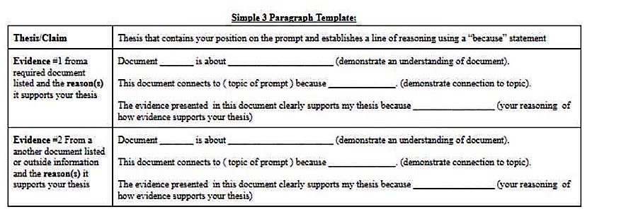

Modified 2020 Argumentative Essay Grading Rubric & Check Sheet

A1 | Thesis/Claim | Thesis or claim that establishes a defensible argument related to the prompt. There are two parts:  - Answer the question the prompt is asking with a thesis or claim  - Establish a line of argumentation or reasoning.  *You must earn a point on your thesis/claim in order to get B2, B3, C2 or C3 points. | / 1
B1 | Document 1 - Given in the prompt | The prompt will provide three core documents to select from. You will earn a point if you select a document that relates to your claim. | / 1
B2 | Document 1 - Given in the prompt | This point is earned if you show evidence that you understand the document. | / 1
B3 | Document 1 - Given in the prompt | This point is earned if you can give reasoning as to why your first document supports your claim. You must explicitly tie the document to your claim. | / 1
C1 | Evidence 2 - Provided by the student | The prompt will require that you use a second piece of evidence that is provided by you (any document, Supreme Court case, or other piece of evidence from class learning) that relates to the prompt and your claim. | / 1
C2 | Evidence 2 - Provided by the student | This point is earned if you show the reader that you understand the evidence that you provided. | / 1
C3 | Evidence 2 - Provided by the student | This point is earned if you can give reasoning as to why your second piece of evidence supports your claim. You must explicitly tie the document to your claim. | / 1
 |  | Total Score | / 7

For further study, using an example, please reference this video from teacher Carey LaManna.

